1. **ls** - Lists a directory’s content

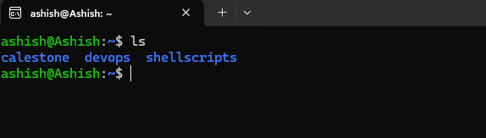

1. **pwd** - Shows the current present working directory’s path

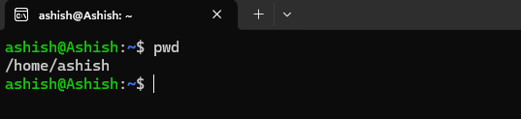

1. **cd** - Changes the working directory

**Example:** cd devops will change directory to devops

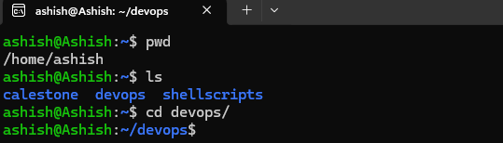

1. **mkdir** - Creates a new directory

**Example:** mkdir dir1 will create a new directory as dir1

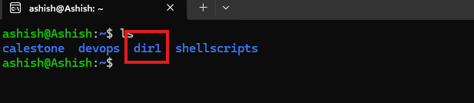

1. **rm**  - Deletes a file

**Example: rm** –r dir will remove the directory dir. In this command we have used –r flag which mean recursive

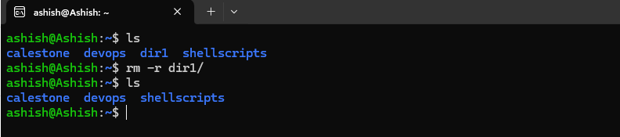

1. **cp** - Copies files and directories, including their content

**Example**: cp –r shellscripts devops will copy shellscripts directory along with the file in shellscripts directory

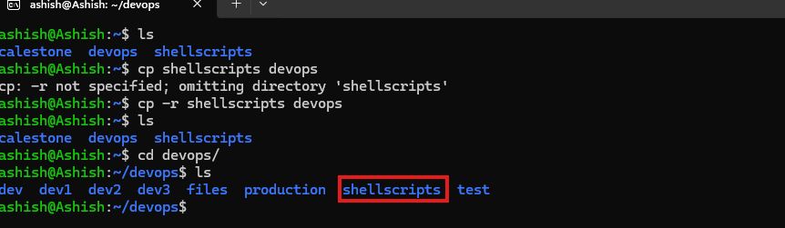

1. mv - Moves or renames files and directories

**Example**: mv shellscripts scripts will rename shellscripts to scripts

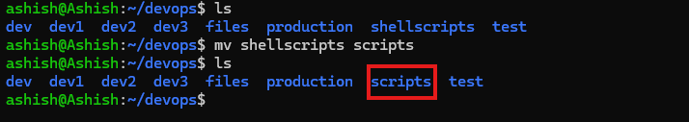

1. touch - Creates a new empty file

**Example:** touch test.txt

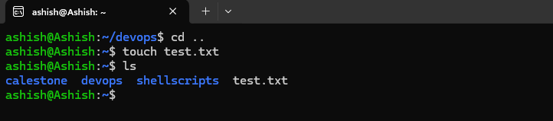

1. **zip and unzip** - Creates and extracts a ZIP archive

**Example:** zip –r files.zip files, will create a zip file. Also we need to make sure we have zip installed on your system if not **“run sudo apt install zip”** then run that zip command

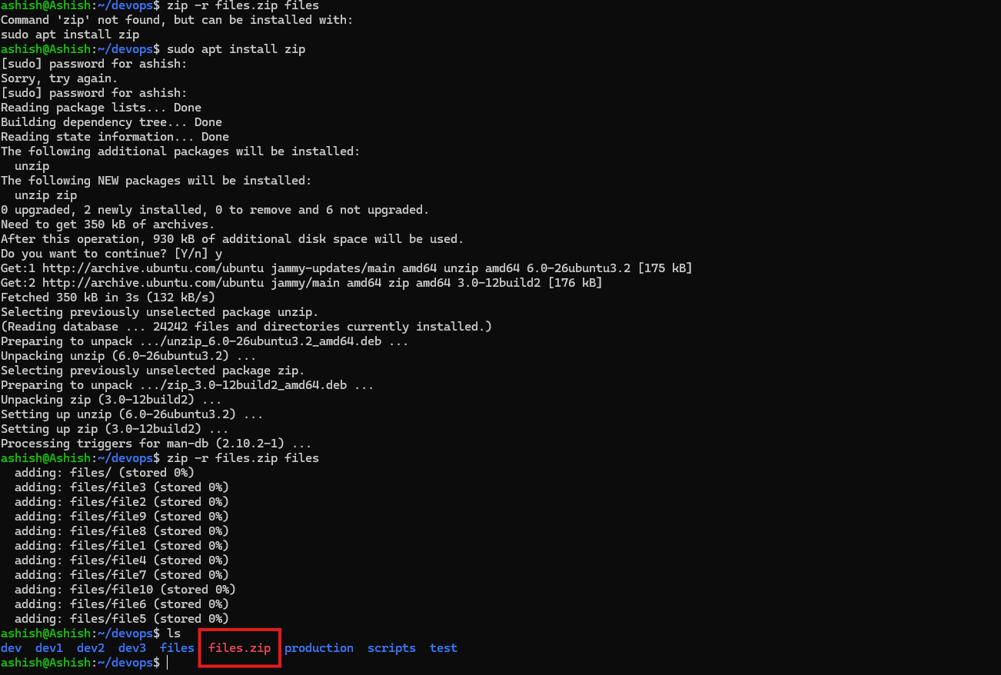

1. tar - Archives files without compression in a TAR format

**Example:** tar -cvf files.tar /home/ashish/devops/files

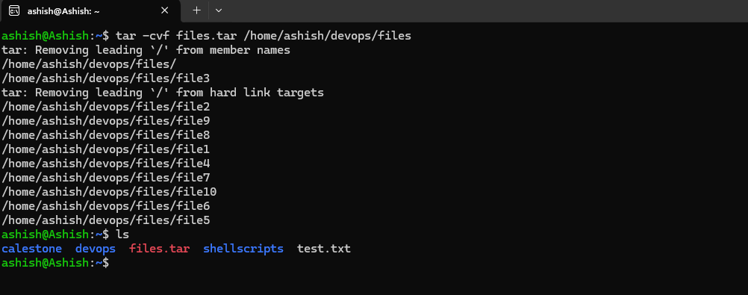

1. nano, vi, and jed- Edits a file with a text editor

**Example:** vi test.txt

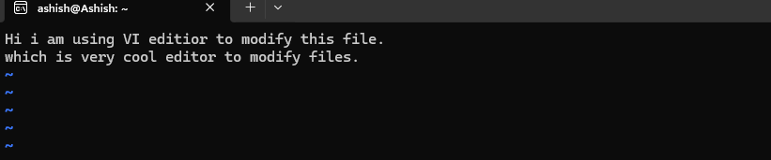

1. **cat** - Lists, combines, and writes a file’s content as a standard output

**Example:** cat test.txt

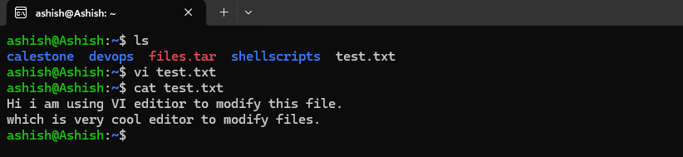

1. grep - Searches a string within a file
2. sed - Finds, replaces, or deletes patterns in a file
3. head - Displays a file’s first ten lines
4. tail - Prints a file’s last ten lines
5. awk - Finds and manipulates patterns in a file
6. sort - Reorders a file’s content
7. cut - Sections and prints lines from a file
8. diff - Compares two files’ content and their differences
9. tee - Prints command outputs in Terminal and a file
10. locate - Finds files in a system’s database
11. find - Outputs a file or folder’s location
12. sudo - Runs a command as a superuser
13. su - Runs programs in the current shell as another user
14. chmod - Modifies a file’s read, write, and execute permissions
15. chown - Changes a file, directory, or symbolic link’s ownership
16. useradd and userdel - Creates and removes a user account
17. df - Displays the system’s overall disk space usage
18. du - Checks a file or directory’s storage consumption
19. top - Displays running processes and the system’s resource usage
20. htop - Works like top but with an interactive user interface
21. ps - Creates a snapshot of all running processes
22. uname - Prints information about your machine’s kernel, name, and hardware
23. hostname - Shows your system’s hostname
24. time - Calculates commands’ execution time
25. systemctl - Manages system services
26. watch - Runs another command continuously
27. jobs - Displays a shell’s running processes with their statuses
28. kill - Terminates a running process
29. shutdown - Turns off or restarts the system
30. ping - Checks the system’s network connectivity
31. wget - Downloads files from a URL
32. curl - Transmits data between servers using URLs
33. scp - Securely copies files or directories to another system or local machine to remote server
34. rsync - Synchronizes content between directories or machines
35. ifconfig - Displays the system’s network interfaces and their configurations
36. netstat - Shows the system’s network information, like routing and sockets
37. traceroute - Tracks a packet’s hops to its destination
38. nslookup - Queries a domain’s IP address and vice versa
39. dig - Displays DNS information, including record types
40. history - Lists previously run commands
41. man - Shows a command’s manual
42. echo - Prints a message as a standard output
43. ln - Links files or directories
44. alias and unalias - Sets and removes an alias for a file or command
45. cal - Displays a calendar in Terminal
46. apt-get - Manages Debian-based distros package libraries